**Linear Discriminant Analysis**

**Linear Discriminant Analysis (LDA) is a methodology for reducing dimensionality in supervised classification problems. It's used to represent gaps between groups, such as separating two or more classes. It's a technique for projecting features from a higher-dimensional space to a lower-dimensional one. Image recognition and other marketing applications use this method of dimensionality reduction.**

**This dimensionality reduction technique assists in the exploration of two areas: parameters that can be used to describe the relationship between a group and an entity, and a classification preceptor model that can be used to assist in group separation. LDA is commonly used to model various types of varieties because of this. This method can be used to spread a variable between two or more groups.**

**LDA can classify objects into binary and multi-class categories.**

### How does an LDA model make predictions?

**Bayes' Theorem is used in LDA models to estimate probabilities. They make predictions based on the likelihood that a new input dataset would fall into one of the groups. The output class is the one with the highest likelihood, after which the LDA makes a prediction.** **The prediction is made using Bayes' Theorem, which calculates the likelihood of the output class given the input.**

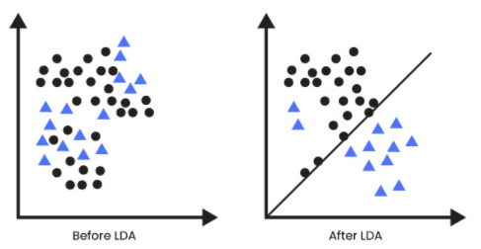

**Source:** **www.analyticssteps.com**

**Common LDA applications**

**LDA is used in a variety of applications. It is applicable to any problem that can be converted into a classification problem. Speed recognition, face recognition etc.**

### **Face recognition**: **LDA is used to reduce the number of features before applying the classification method.**

### **Customer identification**: You can use LDA to collect customer features if you want to identify customers based on their likelihood of purchasing a product.

### **Medical**: LDA can be used to classify diseases into severe, mild, or moderate categories. There are several patient parameters that will be considered when performing this classification task.